Based Technology to A

Traditional Way of Cash

Register
I. Problem

When it comes to important days like; Eid Mubarak (Ramadhan), Christmas, or Chinese New Year, people will go shopping in order to prepare for the celebration. Without exception, supermarkets know during these occasion there is always an inflation of people. But sometimes, people tend to be lazy when they see an extremely long queue at the checkout counter from the front door of the store. Especially when there are a lot of closed cash registers that are supposed to be opened. In this circumstances, sometimes we might pondering one question, “Why do they make a lot of cashier’s desk when they are just going place it as a decoration?” Certainly, as a consumer we want everything just so fast, unlike the queue problem we mentioned before.
However, if we could position ourselves as the manager, it’s clear that the reason why we closed some of those cashier’s desk so that we can save more energy as well as the cost. Let’s make a count for it, imagine that the utility cost they spent for one cash register about US$26.70 per month. Added with the wage expense for the sales clerk, based on the minimum wage in Jakarta (the capital city of Indonesia) for 2018 is US$257.67 every month. So, if we sum it up, the total cost for only one cash register would roughly be about US$284.37 each month. After looking at the computation, we might find it quite interesting because a simple thing such as cashier register turns out having a high cost.
Aside from the perspective of consumers and managers, there is still one more important role inside the supermarket, which is sales clerks or workers. As a human, we normally have a difficulty and tend to work slowly in doing multitasking job, just like what most of sales clerks did. Based on the reality, their task is starting with scanning items, continued by making a receipt for the buyers, ended with putting the consumer’s stuff inside a plastic bag. And in such a crowded situation, their tasks are compounded by the time limit they have to reached. So no wonder if the queue just keep the same and even getting longer.
Living in the 21st century, technology and internet has gradually become a basic need for everyone. With it, most of the works could be easily and rapidly solved. And as we addressed the former problem in the supermarket before, we think how to manage the traditional system of cash register problem with more sophisticated substitution oriented in internet or other comparable technology. Therefore, we assure that the outcome will be satisfying for all parties, like consumers, managers, and workers.
II. Idea

After studying the issue, we generated ideas based on the multiple number of customers that were lining up at several supermarkets. We gathered some information from our family, friends and relatives by questioning them about how their experience was in the supermarket. Through the output, we found out the customers were unsatisfied with the cashier’s service. The ideas we came up with weren’t just based on the interviews, through our very own experience as well, we were unhappy that even though we live in such a technological era, we still couldn’t do grocery shopping online, this was something we thought we could advance in.
While we were observing the supermarket, the cashier was someone who we needed to consider, as the fact we know that mostly all the services in the supermarket was provided by the cashier alone. Almost all of the factors that determining customers’ satisfaction come from the cashier services. We thought that actually some of the things that used to be done by the cashier can also be done by the customers themselves. This kind of deliberation helps us to develop those ideas which will move part of the cashier’s job to the hand of customers without make them feel bothered.

III. Alternative

Having noticed of how inconvenient the lines were for the customer, we come up with the solution to make the customer do not have to wait for a long time. By doing this, we start to think of the world that we live, and how easy it is to access anything through your fingertips and scanning systems.

BARCODE SCANNER

While we were observing customers and within our own experience, we found out the amount of time it took for the cashier to scan the barcode for each item and pack all things consume a lot of time. Therefore, we came up with the idea of giving every customer a barcode scanner. As soon as the customer gets into supermarket, it is available at the entrance, the customer doesn’t have to register as the machine can be used directly. At the back of every barcode scanner there will be a QR-code, for the cashier to scan how much all the items a customer has picked cost.
When a transaction has been completed, it is then transferred to the main system. The data in the barcode scanner will automatically be deleted. The cashier’s job at the end,
will be scanning the QR-code and having the customer receipt. This will make the job for the cashier easier and they will not be frustrated at the end of the day. Also, it will shorten all the lines at supermarkets.
When the customer is finished purchasing his items, there will be an area set up for them to put all things they have bought from their trollies into plastic bags. The barcode scanner will be given back to the cashier once the customer has paid off their amount.

SELF PAYMENT

Secondly, instead of always going to the counter, we have an alternative way of pay it yourself. A simple way of purchasing things without involving a cashier. A lot of people in the world we live in tend to have either debit or credits cards, so all what they must do is scanning the items they want and paying it by themselves. After the customer has decided on the items they want, there will be a special booth for them to prevent anyone from trying to steal things. There will be eight stalls in a booth inside the supermarket with only one entry door and one exit door. The exit door will have an alarm system for anyone who tries to steal. Once the customer has finished and has paid for his items the computer system will transfer all the data to the main frame and the credit or debit cards records are deleted. This can insure the customer personal information safety. Supermarkets can provide these machines for those people who wants to do everything by themselves, but there is still the option of cashier counter. However, this machine will not be able to take in cash.

TRIPLE FUNCTION APPLICATION

We generated our last idea based on the reality that we live in the era of industrialization

4.0 and internet connection. This made us create the idea of making an app for making the cashier operating system easier for both the customer and the cashier. For this idea we had several ways, to make it more effective and efficient.
First, we will design an application that enable customers to access the information about different items in different categories that are available in the supermarkets. There is also an option of searching for the items they want. This therefore, makes it easy to identify what is available at the store, while you are still in the comfort of your own home and decide whether we can go to that supermarket and get what we want. This application can help them with making a list of things they want to buy beforehand, so that when they reach the supermarket all they have to do is put items in their carts or
shopping bags. When you add an additional item all you to do scan the barcode on the price tag with camera button on the application. After the customer has finished getting the items they want, the application will give them the verification number and total amount, all they have to do next is go to the cashier and give them the verification number. The verification number will automatically connect to the system and give out the correct data, all the customer have to do is pay.
This application can notify the main frame, when a person opens their application and they are present in the store. With this information we are able to adjust (balance) the number of opened cash counters, with the number of people in the store. After every twenty minutes the footprint of people will be updated.
Through this App there will be an option whereby the customer can choose to get shopping delivery to their homes. However, in-order for this to work, we will first start off on a small trial for approximately three months and observe how success it is in attracting multiple customers. If it works well, then the CEO’s can consider implementing this project permanently and draw up a contract with a motorbike-based
delivery company such as GO-JEK.

IV. Decision Making

BARCODE SCANNER

We decided that the Barcode Scanner is not going to be a success option, because a lot of problems could occur during the usage of this equipment. For instance, when the customer wants to cancel an item, they would have to wait until someone comes to help or until they get to the cashier. Another default with this idea is, after a while the barcode scanner starts to deteriorate and the scanner sensitivity decreases. This makes it hard to scan an item, especially if the item is frozen because the item’s barcode can not be recognized or readable. We would need to have an introduction period to help customers understand the new system and how it works.

SELF PAYMENT

The Self Payment; had started off with being a self-service idea but we realized that it wouldn’t be a good idea, because people wouldn’t be pressured to hurry up and finish buying what they need, it would be all on their own time and pace. We also noticed a lot of people would lose their jobs, because more people would resort into doing it
themselves. With this idea there is a higher chance that a lot of people can steal, so it is a very high risk.

TRIPLE FUNCTION APP

The Triple Function App is the main idea we would like to propose. We found this idea is suitable for the world we live in that is evolving every day. This application is flexible to apply into your lifestyle. A wider range of jobs will be created due to this application. When a customer is at the store, and wants to purchase something, there is a reduction of error in the barcoding system. For example, if the item you want doesn’t have a barcode or your phone can not read the barcode then the customer has the option of searching for the item.
This application can help reduce the amount of time spent shopping and questioning whether-or-not the supermarket has the item. It makes it extremely better for customers as they don’t have to wait for a long period of time to get cashier. The cashier’s job becomes lightened, because they don’t have to handle the physical work when it comes to being on the counter anymore, all they are involved in mostly is the payment. The pressures and frustrations of the cashiers are decreased.
The employer doesn’t have to speculate how many people enter the shop and decided how many cash counters should be open based on that speculation. The employer can now based his decision on the real data he has from the main frame which has calculated how many people are in the store and determine the number of cash counters opened. The employers can benefit from knowing that their customers are increasing because of the services that are provided.
In conclusion, we came up with this decision to choose the TRIPLE FUCNTION APP, inconsideration of minimization errors and will make it easier to apply into our daily lifestyle.

V. Application

This application will be based on the concept of Native App. This intel’s business programs, educational apps and entertainment apps. The Native App has the top of the line security and it has the best performance status. Based on the information we got on
the “Kinvey survey, 100 iOS, Android and HTML5 developers” diagram 1 , we estimated it would take an average of 18 weeks (4-5months) to program the engineering
progress when the engineering part of the app has been completed, it is prepared to be publicly released. The design and creativity aspect of the app would take another several weeks. In some scenarios, we could find ourselves taking more than the time we have estimated, depending on our team capabilities. Besides, we also need some several weeks (1-3 months) advertisement time about this launching application to tell the customers that in a few months, they will need to download the application and use that application to shop in the supermarket. On the other hand, we need to give the workers some training program to let them familiar with overall system. After the application is launched, we need to give probably around 1-3 months of trial period while socializing about the application and how it works before we completely removed the previous way of doing both payment and packing in cashier.
To organize and program an enterprise mobile app it is indeed very costly. As we were researching, for the criteria of our application, we would estimate to spend about USD$200,000-$350,000, which we established by the USD$270,000 average price we got from the Kinvey survey “State of Enterprise Mobility”2.
The price will increase depending on the complexity of the application. In order for the application to be successful the supermarket would have to sacrifice a lot of time, money, and energy. A lot of money would have to be invested to make a high complex application with multiple features, that will enable customers to use it effortlessly. The supermarket also has to be prepared for the negative reaction they might get from the public, especially on their first launched. Rejection from the middle-age people or older people is something that the supermarket can’t avoid but need to face it sooner or later. We therefor need to come up with a strategy that can help those people adapt to the new system and enjoy it. Let’s say for the first period of time, when this new system is launched, the supermarket needs to assign some workers do the socializing program or even assign workers to accompany some of the middle age customers and explain in detail how to access the overall application. This application lets everyone enjoy the
joyfulness of shopping. During the trial period, all the cashier needs to do is tell the

1 “How Long Does it Take to Build an iOS or Android App?” https://www.kinvey.com/wp- content/uploads/2013/01/how-long-does-it-take-to-build-an-app-kinvey-1500x834.png
2 “State of Enterprise Mobility”, November 2014, p3
https://resources.kinvey.com/docs/State+of+Enterprise+Mobility+Survey+2014+-+Kinvey.pdf
customers that after the trial period has ended, they will need to be prepared for the whole new system.
Applying this idea indeed needs a lot of preparation and new marketing strategies, but once it’s succeeds, both parties will enjoy the result, which makes every single effort we have put in become worth it. A whole new cashier system, for a whole new shopping experience.
APPENDIX

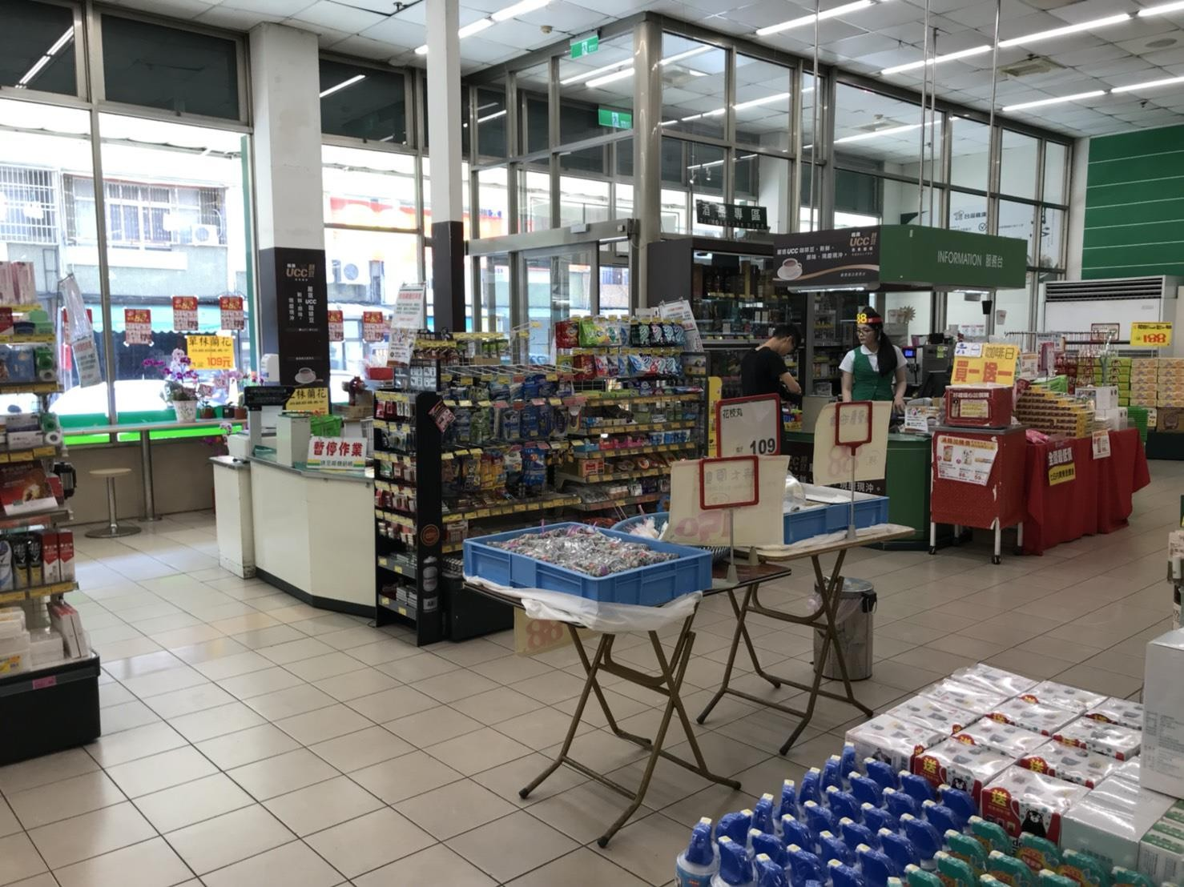

Figure 1. Taiwan’s supermarket condition during weekdays.

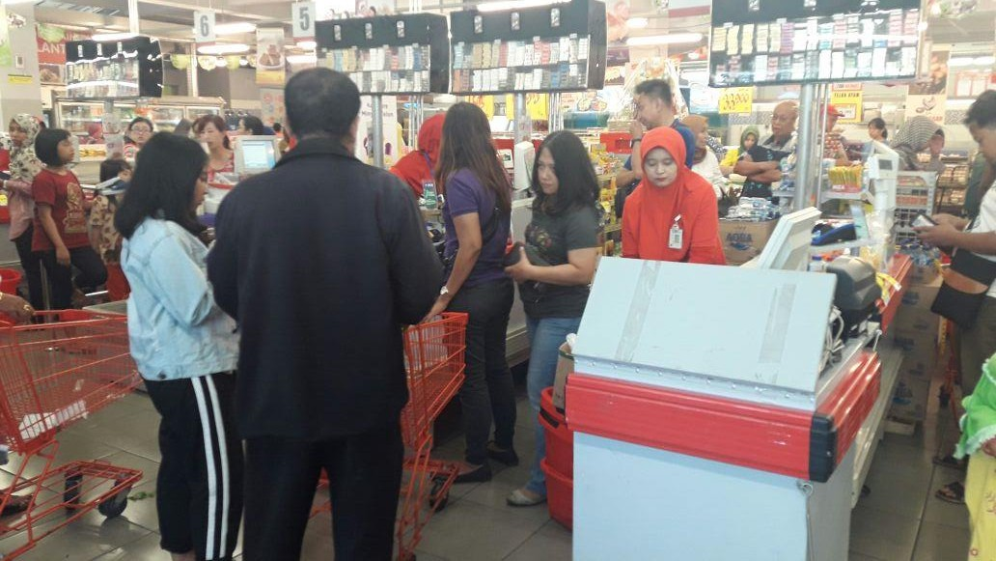

Figure 2. Indonesia’s supermarket condition during Eid Mubarak (Ramadhan), long queue in cashier
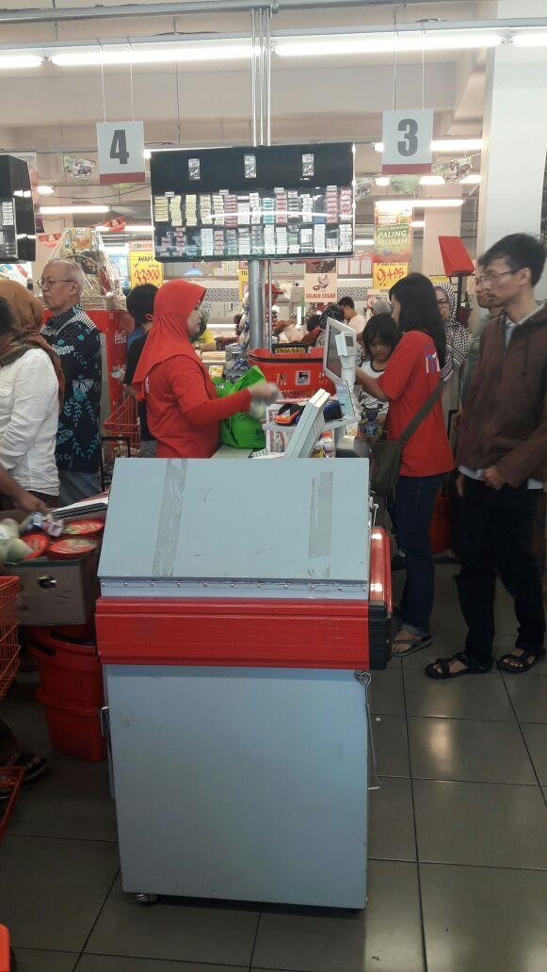

Figure 3. Cashier in Indonesia’s supermarket responsible in scanning the items’ barcode; packing the items bought; and payment

