in Supermarkets

Supermarkets are one of the essential parts in human daily routinity. We fulfill our daily needs through the goods that are provided by supermarkets. Thus, people usually spare a few moments or hours to go to the supermarket. The focus of our study is to reduce the time it takes for customers to go shopping by reducing the frequency of queuing lines that are being created and if possible, eliminate it. Of course, it is not possible to do this without also analyzing the cost and space it needs from the supermarket itself. The subject of our study is Indonesian supermarkets. The goal of our study is to make Indonesian supermarket to be more efficient and able to keep up with the modern trends of Hema supermarket by Alibaba and alike. We will now continue to discuss what we discover and what we want to change or create for the current supermarket system on the points below.

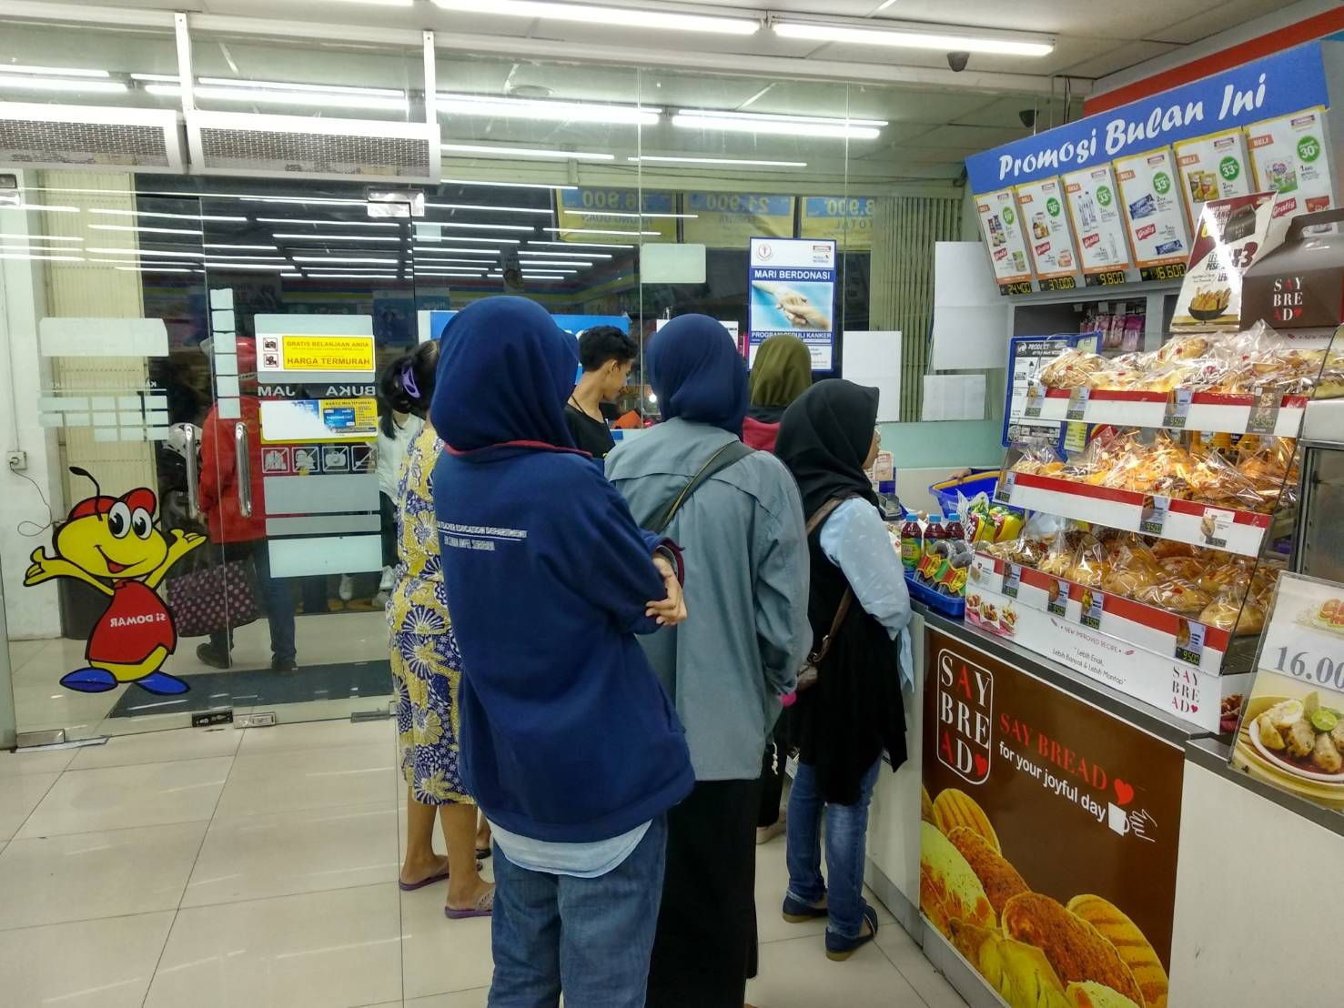I. Problem

Picture 1.1 Queue at cashier

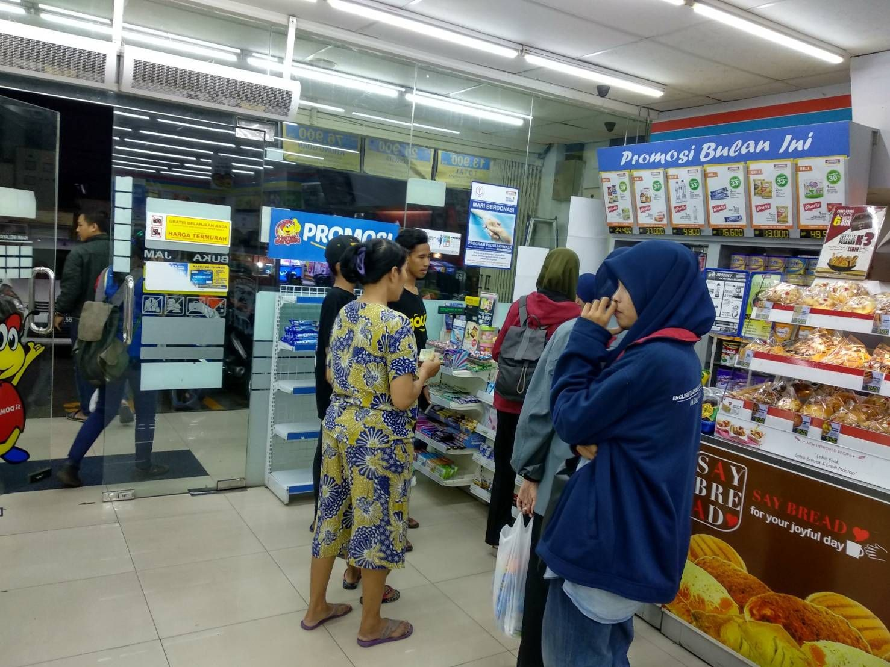

Picture 1.2 Queue at cashier

Supermarket from all around the world is starting to change. With the arrival of Industrial 4.0, available cashiers are slowly changing to be automated. Meanwhile, no Indonesian supermarket are using automated system for their cashier. This causes inefficiency in the cashier system of Indonesian supermarkets. The expectation of supermarket owners is that the current cashier system is already as good as it is. The mindset of supermarket owners in Indonesia is also focused on opening an optimum number of new cashier, not on improving it. Meanwhile, the customers don’t care about how many cashiers are available.

What customers do care about is time efficiency. They don't want to queue to pay for their goods. They already spent enough time to shop for their daily goods and wanted to pay without the need to wait for someone else to pay too. We think that this are the causes of queuing line inefficiency in Indonesian supermarkets. Therefore, we’ll try to innovate on the current cashier system of Indonesian supermarkets.

II. Idea

The idea is to create a shopping system on a supermarket which will help the consumers when they’d like to pay for their goods. Consumers don’t have to waste their time queuing in front of the cashier to pay for their goods. Consumer satisfaction will also be likely to increase because of the freedom they’re given to use their time efficiently.

III. Alternative

● RFID system as a cashier person replacement and a phone to be scan for the method of payment.
Consumers would go to a supermarket taking all the items they would like to buy. After the consumers finished taking the items, they can go straight to the cashier. We won’t be needing a cashier person to do the barcode scan of each item. Instead, we’ll put the items on a conveyor which runs automatically and will go through a huge scanner that scans for the item that are passing through. Every product which consumers would like to buy will be automatically updated to the supermarket’s database. The list of each item will be displayed on a computer with all the prices that has already been set. Of course, the scanner will be having a hard time reading small barcodes. So, we’ll replace the barcode with a bigger RFID tags.

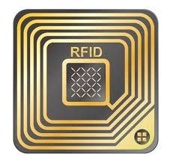

Picture 3.1, An example of RFID tags that we’re going to use.

Finally, customers can use their phone as a payment method. They’ll have to download the apps which will ask them to input their bank account number. This will help the scanner to identify which bank account will the supermarket be taking money from. Each payment will require the customer to input their pin number of the bank account. After the payment has been done, the app will display on how much money does the supermarket debit from their bank account.

● Smartphone application

This application suggestion are quite different than the application on the first alternative that we’re going to use. This application helps the consumers to choose the items that they’re going to buy. This application displays the nearest supermarket available and what items are available there. Of course, we’ll also display the prices of the items on the application that we’re going to make. Consumers must have an account that will be used as a payment method. Our application will ask the consumer to give their bank account number when their signing up. After signing up, consumers can order what items they’d like to buy anywhere and anytime. They can pick the items that they’ve ordered on the nearest supermarket that are displayed on the application. Consumers will be doing payment via application which has their bank account number. Before confirming the purchase, consumers will be asked to enter their pin number.

They’ll receive a barcode that they can trade in the supermarket afterwards at the cashier person. The items which they’ve ordered can be confirmed by the cashier person, as of the list of items that have also been received by the cashier person via application. The cashier person should also holds an account of the supermarket itself to know the orders that are coming in. Orders are only valid after a customer confirmed their payment.
● Drive Thru Supermarket

The fact that shopping in supermarkets is a routinity hated by many people and online services have become increasingly popular as a way for customers to avoid crowded aisles and the struggle of carrying heavy bags, we’re coming up with the third alternatives. Our third alternatives will be “Drive thru Supermarket”. Drive Thru Supermarket is a supermarket where consumers don’t need to get out from their car to shop or even take the items that they’ve paid for. In fact, they could pay it online via an application that we’ll be making. This is how the “Drive thru Supermarket” will work. Consumers could choose the items that they’d like to buy and also it’s quantity. The application will then display how much will the consumer be needing to pay. This payment is done online and it can be done through Mart-Pay. Mart-Pay is just like other payment services like Go-Pay in Go-Jek, Steam wallet in Steam, etc. If the consumer is having trouble with this payment services, they can always choose to input their bank account number and pay with directly with their bank account. But then, the consumer will be asked for their pin number everytime a payment is about to be made. Consumers that have successfully done the transaction via the application will receive a barcode that can be scanned. That barcode will be scanned when the customer arrives at the “Drive Thru Supermarket” window on the location of the supermarket. There’ll be machines that will process the items that is purchased by the costumer give it to them. Consumers can leave after all the items purchased have been received.

IV. Decision Making

In the process of applying these alternatives, we are aware of the constraints and limitations which supermarket owners have. We will be analyzing the possible limitations and constraints that supermarket owners will be facing when they’d like to take these alternatives. These constraints and limitations will include costs, the available terrain or land, the effort it takes to realize these alternatives, etc.

● RFID system as a cashier person replacement and a phone to be scan for the method of payment.
If we would really like to apply this alternative, we could increase the speed of each payment by customers in each cashier. The cashier person won’t be needing to scan items that the customers purchased one by one. Meanwhile, by applying this alternative we could reduce the risk of the cashier person being negligent.
On the other hand, this alternative do need a relatively high cost. The use of RFID tag on each items is not to expensive. The cost fly high when we’re talking about the program that runs this RFID system. The RFID tag is also unable to be recycle, which mean one RFID tag is only used for one product. We’ll have to continue on producing or buying RFID tag.

● Smartphone applications

If we would really like to apply this alternative, we could cut the time which customers could be spending to shop in the supermarket. We can also guarantee that the queuing line will be much shorter because of the payment method that is simple and the supermarket staff already prepared the ordered items that is about to be taken.
However, the negative side that we found on this alternatives is that we couldn’t guarantee that the risk of the cashier person being negligent is not there. This means that if an event like this happen, it would prolong the queue line.

● Drive Thru Supermarket

Shopping and payment that is done online could reduce the frequency of queue line that is happening on supermarkets. We know that queue line on supermarket do appear and show up because of the time it takes for the cashier person to scan the barcode on each items that the customer purchased and the payment method that takes time. With Drive Thru Supermarket, customers don't have to experience the queue that is frequently tiresome for people. Customers could just take the product that they paid for, and leave. Customers don’t have to wait for the cashier person to do the scanning one by one per items purchased. This is of course very effective for the customers. Drive Thru Supermarket being having no cashier person also reduce the cost it takes to pay monthly wages.
The negative side of this alternative is that the investment cost it takes to create the application for Drive Thru Supermarket is relatively expensive. We could be spending tens of millions to hundreds of millions Rupiahs depending on the feature that we would like to provide for the apps. The time it takes to make applications is also considered long. This is caused by the time we used to perfect the application and do beta test on the application, which will also be needing a competent programmer to do this. We haven’t even calculate the operation cost of the supermarket system takes. Beside the cost of creating the application and the system, we also like to consider the cost it takes to purchase the wide and large land it takes to build this supermarket. Furthermore, the investment cost of this alternative could reach hundreds of rupiahs.

V. Application

By considering all three alternatives that are available, we would like to apply the second alternative which is using smartphone application. This application helps consumers in ordering the items they’d like to purchase and the probability that they have to queue in line at the cashier because of the payment method is low if we hire a cashier person that is not negligent and thorough. The investment cost it takes is also relatively cheap if compared with the other two

alternative. This alternative is also likely possible to be applied. We only have to make a simple application on the application store that is available on phones and download it.

