[TCS]2

“Time Trimming, Cost Cutting, Space Saving”

JOEY team

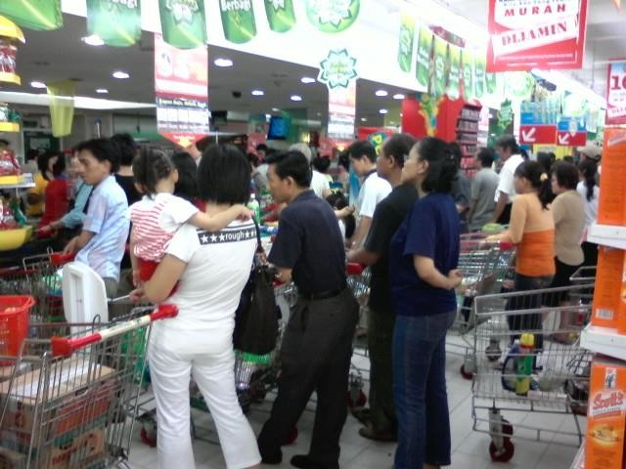

I. Problem

Economic development attributes and enables more people to spend more. As more people are able to buy products there will be an increased in the number of visits and transactions happening in stores, supermarkets, and shopping centers. Growth correlates to new problems surfacing, as there are barriers to how much one can grow. Barriers like time constraints, cost, and space deficient inhibit a process to advance beyond their own state.
Time spend on queuing are one of the challenges that are faced by both customers and supermarkets. From the perspective of a customer, queuing is a waste of time and a drag. On a busy day a person can spend 10 to 20 minutes just to buy some groceries. As a customer, he/she would prefer for the queue to flow faster. But a supermarket benefits from a long and slow queue for the more time spend waiting on the line, a customer can be persuaded to spend more on the products placed near the vicinity of checkout counter. Products like chocolate bars, candies, and etcetera contribute to the sales number on that supermarket. An improvement can’t neglect both sides of party. Accommodating the needs of the many outweighs the needs of the few.
According to the data collected by American Time Use Survey (ATUS), an average person spends 40.14 minutes for shopping in a week. This task of going for groceries is a huge burden on time-pressured customer.

II. Idea

• We observed the development of technology in other countries like China, based on their cashless society. People in China use their mobile devices to do transactions. There are no cash involved whatsoever. Some people there haven’t even seen cash for a year or more. Traditions such as giving out HongBao (red packets) have been done through mobile payments app like Alipay, Wechat Pay, etc. The utilization of smartphone, internet infrastructure and banking are immense. The purchase data is used by these companies to know consumer behavior and other numerous types information.
“Data is the new oil.”

Clive Humbly, UK Mathematician and Architect of Tesco’s Club Card (Tesco :

large western chain supermarket)

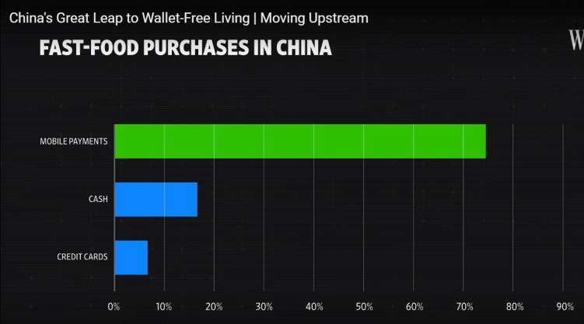

(Picture 1.1 : IPSOS Research Report)

Indonesia already have several cashless payment system already running, they are just waiting to be used. Mobile payments app such as OVO, Go-Pay, DOKU Wallet, T-Cash, etc. are available to be used by the masses. But aren’t used to their potential.
• Based on a personal experience during a visit to Japan by one of our member, he stated that at each room in the hotel there are mobile devices to be used by hotel guests, free of charge. These mobile devices can be used as a guide, map, mobile hotspot, dictionary, etc.

• One Line Multiple Server is a common queue line design used in airport, theme park (Disneyland, Universal Studio,etc), ticket’s counter, stadium, etc. This system are rarely seen in supermarket as the system used there are Multiple Line Multiple Server. This system works best to handle massive load of people.
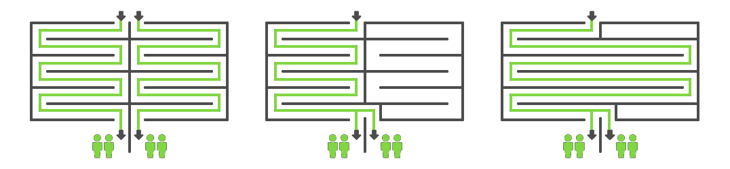

(Picture 1.2: Queue Line Design of One Line Multiple Server) A faster flow, because
• The barcode scanning capabilities of mobile devices (smartphones). Android devices have a feature that is called Google Assistant, within this function exist Google Lens. A program that can analyze an object based on its visual attributes, text, code (QR code, barcode,etc). It can identify certain object and product. The service is not yet reliable ( identifying a product need several trials ). But its capability to read texts and codes are superb, due to earlier advancement in code - text reading capability that exist prior its development. The same applies to Apple products (with its own in-house feature). Hence there are no lag or literal weakness to this form of technology.

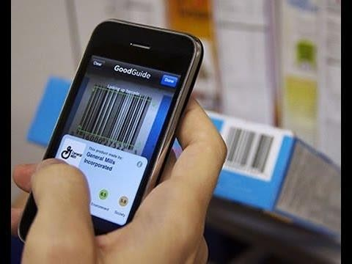

(Picture 1.3: Barcode Scanning App)

• Ever wonder why there are mirrors and windows on elevators? This is to distract the attention of someone. This has been used since 1900s. As New York City was rife with line rage. People who worked in office tower lobbies and had to crowd together and wait for elevators. Obviously, tearing down the buildings to build new elevators would not solve the problem quickly, so building owners invented ways to entertain their crowds. Floor-to-ceiling mirrors were particularly
effective. They caused distractions and even some flirting, which made the waits fly by.

III. Alternative

One of the focus points is making an efficient and basically faster cashier system. Bottleneck happens during the whole transaction process in the checkout counter. A process based on human interaction and manual labor. Eliminating human interaction from the whole picture is a fool’s errand doomed to fail one way or another. A factor that a customer favors a certain service provider than the other is the courtesy and friendliness of the people who work at that company. Quality of service should never be sacrificed. How can improvements be made? By eliminating decision making process, combining important processes and implementing better strategy and ingenious designs that can tackle the problem at hand.
Our first idea is to shift the process of individually scanning a customer’s items by a cashier (as per usual) to the customer themselves. Each customer scanned their own selected items picked from shelves using their mobile devices (if their mobile devices aren’t available, then the supermarket can lend them devices to use) as today’s smartphones are able to scan barcode effortlessly. They can then put the item on the shopping cart/basket. A weight sensor will be installed in the shelf and shopping cart/basket to verify if an item has left the shelf, this is done to prevent theft, missing item, overall human error (within a 1 minute window - time may vary). This whole system is based on IoT (Internet of Things) technology. Each devices and

sensors send information straight to the cloud. Then, when the customer arrived to the checkout counters they can simply pay with their account. If they don’t have balance on their account they can simply pay with cash/debit/credit card, but the emphasis on the transaction part of the process here is to pay with a cashless system. We want to base the payment on the cashless system in China. The catch here is that the addition of an algorithm. This algorithm will process information that comes to the cloud network. The basic idea of the algorithm is to discriminate customer based on the volume of probable purchase, specific item in cart, and stock available in store. Information such as how many items a customer purchase, number of customer with large purchases (to control checkout counters-how many to open, how many manpower needed, allocating customer to certain counters), the stock/number of a certain item in the shelf (when – how many to stock in the shelf, how the product fare to visitors, when to launch a discount on certain items ~ to reduce holding cost for an item and clear out easily spoiled-expired products). This system is the archetype of lean manufacturing, as improvements and changes differ based on changes of time. These are just the cherry on top of the ice cream, but the main idea is the chocolate sauce and the cake that is this whole scanning system. We nicknamed it Pre-Scan – Discrimination System or PS-D System (PSDS). This eliminates the whole process of scanning (process of putting the item on the counter desk and scanning each item) and also sped up the payment process, by trying to eliminate the risk on no change available, human counting for the change, and error in giving out change. Biometric authentication (fingerprint, face identification, etc.) is used to authorize the transaction. This whole system can exist in an app. The app works as an information feeder to the cloud (server). This idea can theoretically save cost, as the cost to provide a checkout counter with two workers can be neglected. The requirement of worker is a total of 1/counter. The burden of traditional cashier is divided on both the worker and the consumer. Also, the cost to provide cash register machines, barcode scanner, and other tools are eliminated.
Second idea is to design the queue line to make it simpler, faster, and more efficient to work. We want to apply One Line Multiple Server design. This system
prevents bottleneck, avoiding-mitigating the risk of a down server (checkout counter), saving space, and cost. This is the simulation of queue line in a supermarket, as
Shelf
Shelf
Shelf
Counter 4
Shelf
Counter 5
Shelf
shown below.
Counter 1
Shelf
Counter 2
Counter 3

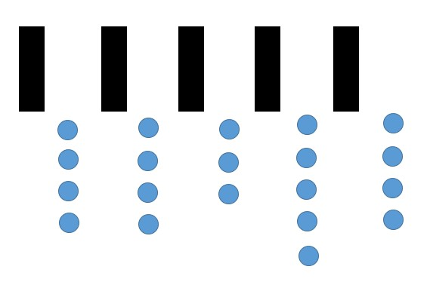± 5 people

Visualization of a busy supermarket checkout using a Multiple Line Multiple

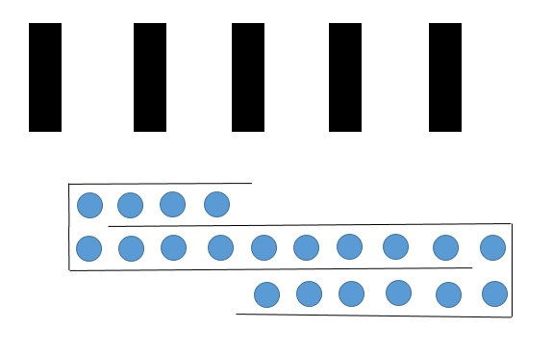Server scenario (number of people : 20).
Shelf
Counter 1
Counter 2
Counter 3
Counter 4
Counter 5

± 3 people
Shelf

Visualization of a busy supermarket checkout using a One Line Multiple

Server scenario (number of people : 20).

already shopping cart with multi-directional wheel, shown below.

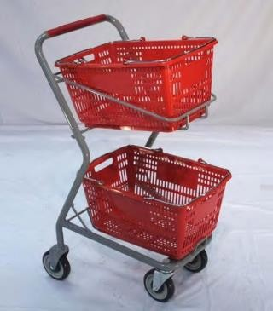

This system eliminates decision making of the customer. Choosing which counter to

go and wait. Taking this “bothersome” task can make the customer more relax.

Third alternative is to mentally make waiting a more bearable task. Visual distractions such as mirrors are to be placed on the queue line. Color choice for the counters can create an emotional state of relax and soothing. Blue is a color that can create that state of mind. Other than that, music is also a great way to make people relax better.

Choosing one of the methods explained before are out of the picture. The technology exists and is being used by the masses. Barcode scanning feature? Check. Mobile payment system? Check. Algorithm that can do that tasks? Check.
We use AHP (Analytical Hierarchy Process ) to determine which is the best way (if we must choose one).

Improvement

1.00

Cost

0,13
Space

0,11
Time

0,42
Easy to apply

0,33
Customer 0,5 Supermarket
0,5

Scanning System One Line Multiple Server Mentally Reduce boredom

Scale of Comparison

Value | Information
1 | Equal
3 | Moderate
5 | Strong
7 | Very Strong
9 | Extreme
2,4,6,8 | In Between Values

Criteria | Cost | Space | Time
Cost | 1.00 | 1.00 | 0.25
Space | 1.00 | 1.00 | 0.25
Time | 4.00 | 4.00 | 1.00
Easy to  Apply | 2.00 | 3.00 | 1.00
 | 8.00 | 9.00 | 2.50

Criteria | Cost | Space | Time | Average
Cost | 0.13 | 0.11 | 0.10 | 0.11
Space | 0.13 | 0.11 | 0.10 | 0.11
Time | 0.50 | 0.44 | 0.40 | 0.45
Easy to  Apply | 0.25 | 0.33 | 0.40 | 0.33

Preferred Value for Easy to Apply (Criteria)

Criteria | Customer | Supermarket
Customer | 1.00 | 1.00
Supermarket | 1.00 | 1.00
 | 2.00 | 2.00

Criteria | Customer | Supermarket | Average
Customer | 0.50 | 0.50 | 0.50
Supermarket | 0.50 | 0.50 | 0.50

Time

Alternative | Scanning | One Line | Mentally
Scanning | 1,00 | 3,00 | 8,00
One Line | 0,33 | 1,00 | 4,00
Mentally | 0,13 | 0,25 | 1,00
 | 1,46 | 4,25 | 13,00

Alternative | Scanning | One Line | Mentally | Average
Scanning | 0,69 | 0,71 | 0,62 | 0,67
One Line | 0,23 | 0,24 | 0,31 | 0,26
Mentally | 0,09 | 0,06 | 0,08 | 0,07

Space

Alternative | Scanning | One Line | Mentally
Scanning | 1,00 | 2,00 | 0,25
One Line | 0,50 | 1,00 | 0,17
Mentally | 4,00 | 6,00 | 1,00
 | 5,50 | 9,00 | 1,42

Alternative | Scanning | One Line | Mentally | Average
Scanning | 0,18 | 0,22 | 0,18 | 0,19
One Line | 0,09 | 0,11 | 0,12 | 0,11
Mentally | 0,73 | 0,67 | 0,71 | 0,70

Cost

Alternative | Scanning | One Line | Mentally
Scanning | 1,00 | 0,20 | 0,20
One Line | 5,00 | 1,00 | 1,00
Mentally | 5,00 | 1,00 | 1,00
 | 11,00 | 2,20 | 2,20

Alternative | Scanning | One Line | Mentally | Average
Scanning | 0,09 | 0,09 | 0,09 | 0,09
One Line | 0,45 | 0,45 | 0,45 | 0,45
Mentally | 0,45 | 0,45 | 0,45 | 0,45

Easy to Use

Consumer & Supermarket

Alternative | Scanning | One  Line | Mentally
Scanning | 1.00 | 0.17 | 0.13
One Line | 6.00 | 1.00 | 0.50
Mentally | 8.00 | 2.00 | 1.00
 | 15.00 | 3.17 | 1.63

Alternative | Scanning | One  Line | Mentally | Average
Scanning | 0.07 | 0.05 | 0.08 | 0.07
One Line | 0.40 | 0.32 | 0.31 | 0.34
Mentally | 0.53 | 0.63 | 0.62 | 0.59

Value

Criteria | Criteria Value | Scanning | One Line | Mentally
Cost | 0.11 | 0.09 | 0.45 | 0.45
Space | 0.11 | 0.19 | 0.11 | 0.70
Time | 0.45 | 0.67 | 0.26 | 0.07
Easy to  Apply | 0.33 | 0.06 | 0.47 | 0.47
 | VALUE --> | 0.35 | 0.33 | 0.32

Meaning, that the best method is “Scanning”.

V. Application

We would apply the best method which is the PSDS (Pre-Scan Discrimination System). Yes it may be hard, but to see it work in other countries is a good indication that it works. The foundation is a system with the help of a mobile app t hat incorporates a barcode scanning, cloud computing and an algorithm that can decide the customer decision before the customer itself goes to the checkout process and “discriminate” the customer based on his/her purchases and item selection. The total amount to pay, the volume of purchase and what is on discount are a few of information that can show up in the mobile device. Payment method will be paid within that app itself. There will be a QR code at the checkout counter. QR code reflects the store/supermarket information and credentials. Once the items have been authorize, then the customer can pay. Authenticating the purchase use not a pin number or signature but with biometric scanner that is already in the device itself. The other details are already written before (@ alternative).

Issues that may surface are that the customer may not be able to use this system well and the supermarket may not be able to utilize this system. But the few basic principles of the system that are cashless payment, scanning QR code, and using a smartphone application are a very familiar scene to most people who have a smartphone. Gojek’s Business Intelligence team in 2017, stated that purchases with GoPay are 50% of every transactions within Gojek. Meaning that people are more and more lean on a cashless society one way or another.

Supermarkets may be lacking the infrastructure needed to apply this technology, but major chains with the capital and resources can very easily apply this technology. Progress of technology is a trickle-down motion, the more people use it the cheaper it gets, a basic economy of scale. The infrastructure is there. Example? The E-toll system in Indonesia, an interconnected network of cards and big data. So saying if the infrastructure is non-existent then it is false argument.

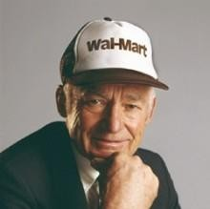“I have always been driven to buck the system, to innovate, to take things beyond where they've
been. “

-Sam Walton-

Founder | Walmart

