EPLE

Efficient . Packing . Table
I. Problem

I. 1. Research Background

Supermarket cashier activity consist of 2 operations, scan barcode and packing. Scan barcode is a UPC scanning process which to add the product into the shopping list. Scan barcode will bring in the total cost people must pay for the product. Packing is an activity which product
is put inside the packaging . The product will be put into the packaging once the product scanned.

Packing takes more time. From the data we have got show that scan barcode activity needs about 1,621 second each product, while packing needs about 1,9775 second every product. So far, packing use an inneficient methode. Packing activity need to be repaired to avoid wasting the time.
I.2. Objective

The objective of this essay is find a cashier table design for the efficient way to pack the product because from the research result, packing takes more time. People these days is a
practical which, the less time they spend, the more money they can save.

1.3. Asumption

The asumption of this research is:

● Use Indonesia conventional cashier system

● Use plastic bag as the shopping package

II. Idea

The idea of this essay is to create a new cashier table model. Concept design of this cashier table is make an efficient packing activity. The idea try to multiple operation in a single operation.
We disscuss with an cashier operator to describe what they needs. The output of this disscussion is the aspect of the cashier. There are five aspect needed by the cashier operator which are :
● Easy to use

● Efficient packing activity
● Ergonomic

● Tender material

● Durable

●

III. Alternative

Manufacture of this alternative table design is to evaluate methods which are going to make. We have threee alternative for this solution. These three alternative are ‘The Hole’ Table,
‘Slide and Go’ Table, and ‘Just Drop It’ table

III.1. The Hole

Concept of hole on the cashier table utilize the gravity as an aids to packing the product. Product that scanned will be slided right to the hole on cashier table. Product that slided will fall into the plastic bag which discharged on the cashier table’s hole.

III.2. Slide and Go

A sloping table cashier have a concept that almost similiar with a “The Hole” cashier table, but reduce the gravity’s effect. The lack of Hole cashier table, the gravity is too strong. Strong gravity cause a stong pressure when the groceries fall into the plastic bag. Sliding table result an efficient packing acitivity with a medium pressure.

III.3. Just Drop It

Cashier table with a hole have a concept that unite packing and scanning process. The scanning process are happen in the hole. The sensor is planted on the hole’s wall. When the groceries are falling, the scan machine will automaticlly scan the barcode. This cashier table needs a new scanner system.
IV. Decision Making

Three alternative selection performed with QFD method. QFD method is a method that consider relation of all the hope of consumer aspect. QFD method consist of few sub-method, which are : House of quality, screening, and scoring.
IV.1. House of Quality

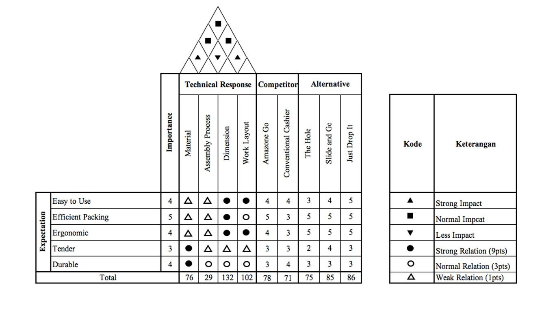

There are five aspects that people expect, there are :

Easy to use, efficient packing, ergonomic, tender, durable

There are four technical aspect that need to be noticed, there are : Material, assembly process, dimension, work layout

After we gather the datas and do research, the result shows that most customers choose the “Just drop it” alternative.
IV.2. Screening and Scoring

From the result, as we can see the data on table 3.1 there are some symbol we need to understand. “0” mean equivalent with the refenrence, “-” mean less than the reference, ant”d “+” mean more good than the reference. The reference is a result that customer choose in the house
of quality. As we see the table, we can compare each criteria with the referencce “Just Drop It”. From the total +,-, and 0, we can conclude that “Just Drop It”, “Slide and go”, and “Amazone go” has the same score. The ranking shows that the three concepts which has “1” ranking are able to
step the next research.

Screening
Selection Criteria | Concept |  |  | Competitor
 | The Hole | Slide and  Go | Just Drop It | Amazone  Go | Conventiona l Cashier
Easy to Use | 0 | - | 0 | + | 0
Efficient Packing | - | + | 0 | + | -
Ergonomic | - | - | 0 | + | -
Tender | 0 | + | 0 | - | 0
Durable | 0 | 0 | 0 | - | 0
Total + | 0 | 2 | 0 | 3 | 0
Total 0 | 3 | 1 | 5 | 0 | 3
Total - | 2 | 2 | 0 | 3 | 2
Score | -2 | 0 | 0 | 0 | -2
Ranking | 4 | 1 | 1 | 1 | 4
Continue? | No | Yes | Yes | Yes | No
Table 3.1
IV.3. Scoring
To get the proportion and fill the scoring table, from table 3.2, we can sum all the result in the matrix, and get the proportion by devide the result and the total. the next step we can move the proportion/presentation into scoring table 3.3.

a | 10 | 9 | 8 | 7 | 6 | 5 | 4 | 3 | 2 | 1 | 0 | 1 | 2 | 3 | 4 | 5 | 6 | 7 | 8 | 9 | 10 | b
a | 10 | 9 | 8 | 7 | 6 | 5 | 4 | 3 | 2 | 1 | 0 | 1 | 2 | 3 | 4 | 5 | 6 | 7 | 8 | 9 | 10 | c
a | 10 | 9 | 8 | 7 | 6 | 5 | 4 | 3 | 2 | 1 | 0 | 1 | 2 | 3 | 4 | 5 | 6 | 7 | 8 | 9 | 10 | d
a | 10 | 9 | 8 | 7 | 6 | 5 | 4 | 3 | 2 | 1 | 0 | 1 | 2 | 3 | 4 | 5 | 6 | 7 | 8 | 9 | 10 | e
b | 10 | 9 | 8 | 7 | 6 | 5 | 4 | 3 | 2 | 1 | 0 | 1 | 2 | 3 | 4 | 5 | 6 | 7 | 8 | 9 | 10 | c
b | 10 | 9 | 8 | 7 | 6 | 5 | 4 | 3 | 2 | 1 | 0 | 1 | 2 | 3 | 4 | 5 | 6 | 7 | 8 | 9 | 10 | d
b | 10 | 9 | 8 | 7 | 6 | 5 | 4 | 3 | 2 | 1 | 0 | 1 | 2 | 3 | 4 | 5 | 6 | 7 | 8 | 9 | 10 | e
c | 10 | 9 | 8 | 7 | 6 | 5 | 4 | 3 | 2 | 1 | 0 | 1 | 2 | 3 | 4 | 5 | 6 | 7 | 8 | 9 | 10 | d
c | 10 | 9 | 8 | 7 | 6 | 5 | 4 | 3 | 2 | 1 | 0 | 1 | 2 | 3 | 4 | 5 | 6 | 7 | 8 | 9 | 10 | e
d | 10 | 9 | 8 | 7 | 6 | 5 | 4 | 3 | 2 | 1 | 0 | 1 | 2 | 3 | 4 | 5 | 6 | 7 | 8 | 9 | 10 | e

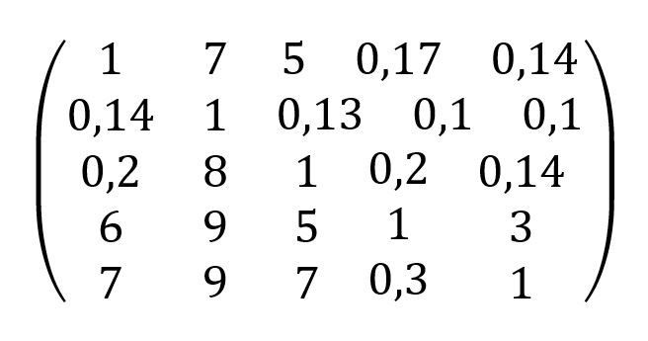

Table 3.2

As the proportion is moved into the table 3.3, we can fill the rating with the result from the data of “House of Quality” The last result of total score and rank shows that “Slide and Go” got the highest score, that is why we product “Slide and Go” table cashier.

Scoring
Selection  Criteria | Weight  (%) | Slide and Go |  | Just Drop It |  | Amazone Go
 |  | Rating | WS | Rating | WS | Rating | WS
Easy to Use | 20 | 4 | 0,20 | 5 | 0,25 | 4 | 0,20
Efficient Packing | 47 | 5 | 0,11 | 5 | 0,11 | 5 | 0,11
Ergonomic | 25 | 5 | 0,20 | 5 | 0,20 | 4 | 0,16
Tender | 2 | 4 | 2,00 | 3 | 1,50 | 3 | 1,50
Durable | 6 | 3 | 0,50 | 3 | 0,50 | 3 | 0,50
Total Score |  | 3,01 |  | 2,56 |  | 2,47
Rank |  | 1 |  | 2 |  | 3
Continue? |  | Yes |  | No |  | No
Table 3.3

V. Application

V.1. Utility

The efficiency of the table structure that makes shopping groceries fall directly to the packaging by simply pushing the goods. Focus on scanning the goods without the need to pay attention to the condition of the arrangement because the goods will be arranged practically only by being pushed. This table has handle that can hold the packaging in the counter so always open and hanging steady. Cashier operators are not difficult to package goods neatly because the purpose of packing supermarket goods only to be brought home with a good and safe.
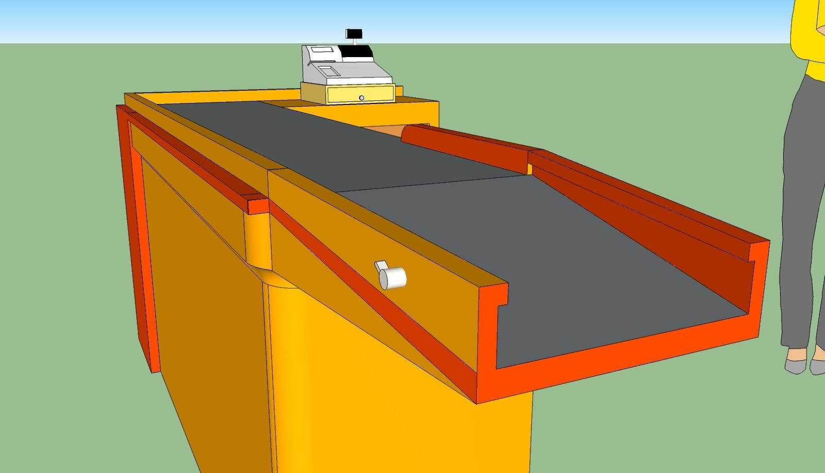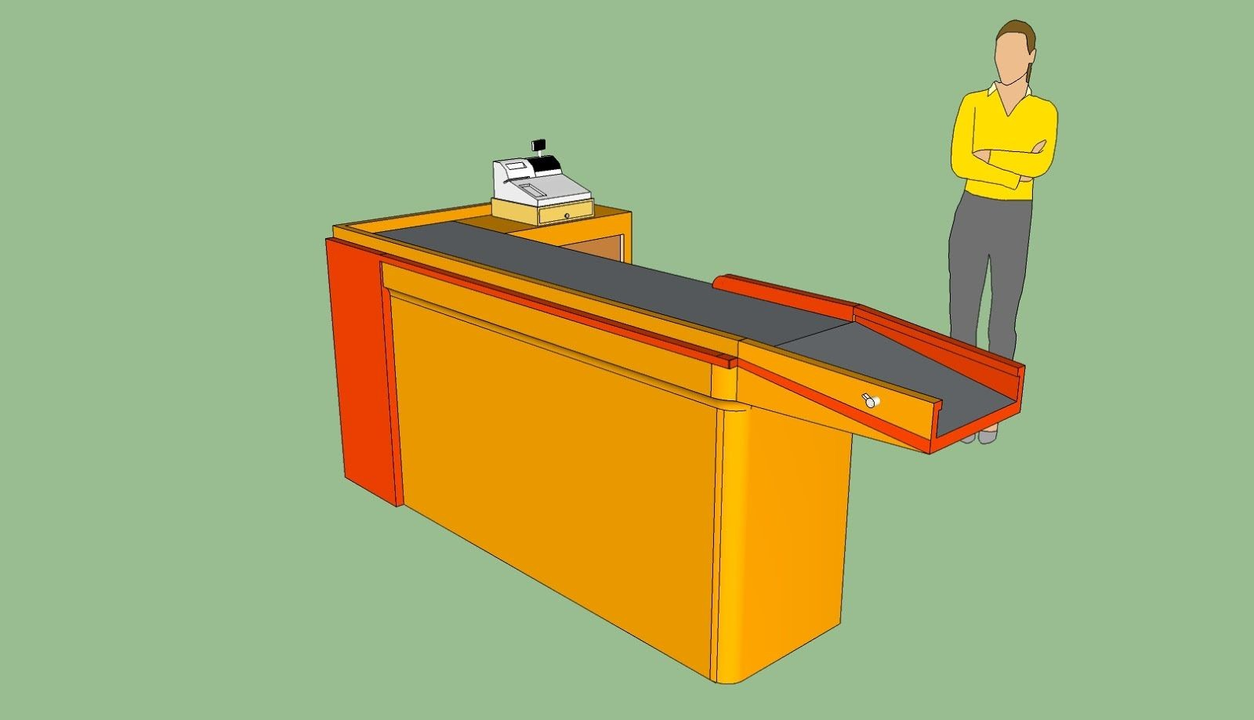
V.2. Appearance

Our Cashier Table have a minimalistic design because of this slide-theme table make it look slim and swift. Yellow is the power of speed, this color want to describe speed in a new way in the cashier system. With the appearance of line and rounded corner want to make it look dynamic and safe from people. Touch of the grey flat surface make it contrast with the groceries to make the operator focus and concentrate.
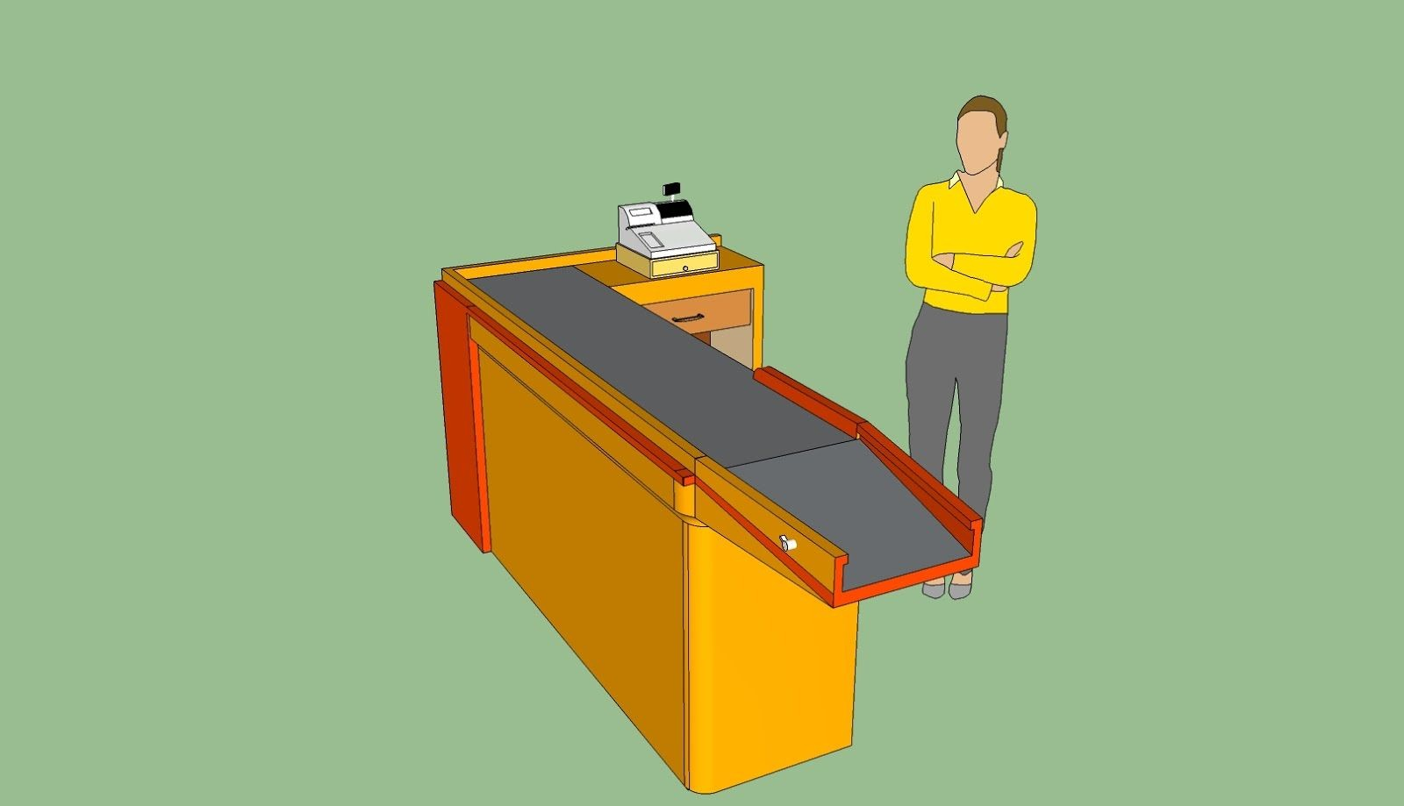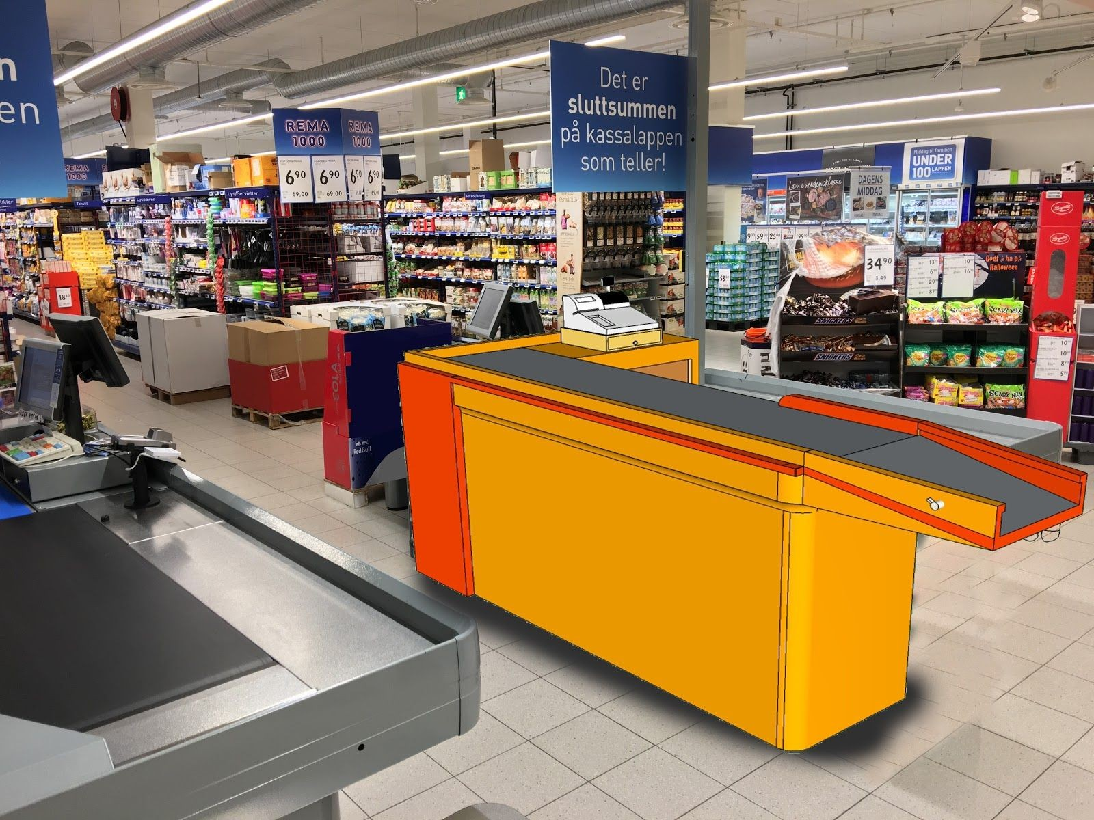

V.2. Ease to Maintenance

This cashier table easy to maintenance because simple and minimalist shape does not have complicated technological conditions to maintenance it. Compared to Drop and Go table has difficult conditions of maintenance of the machine, the system and its own table structure can be damaged and not durable. Solid table structures make maintenance when cleaning easy and not much dust that is difficult to reach.
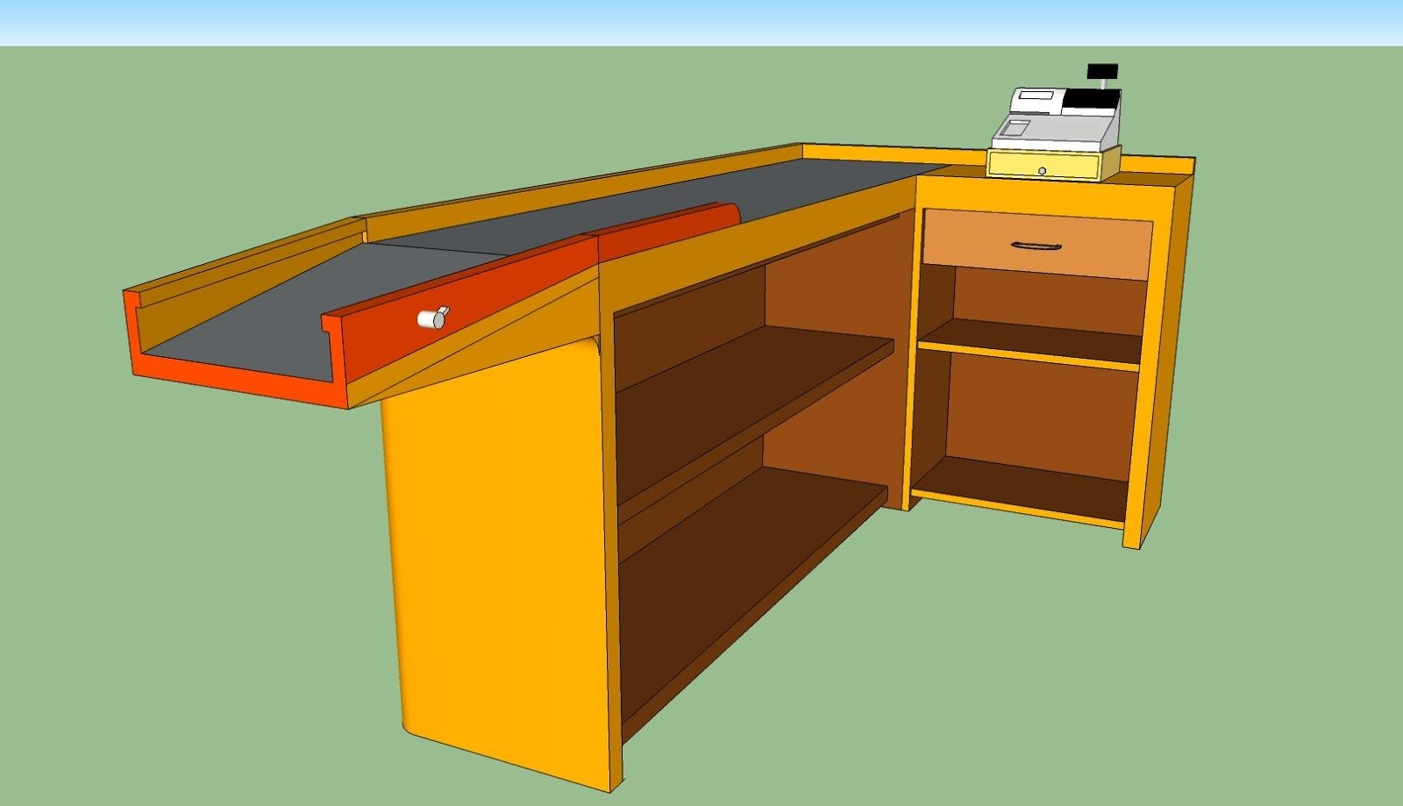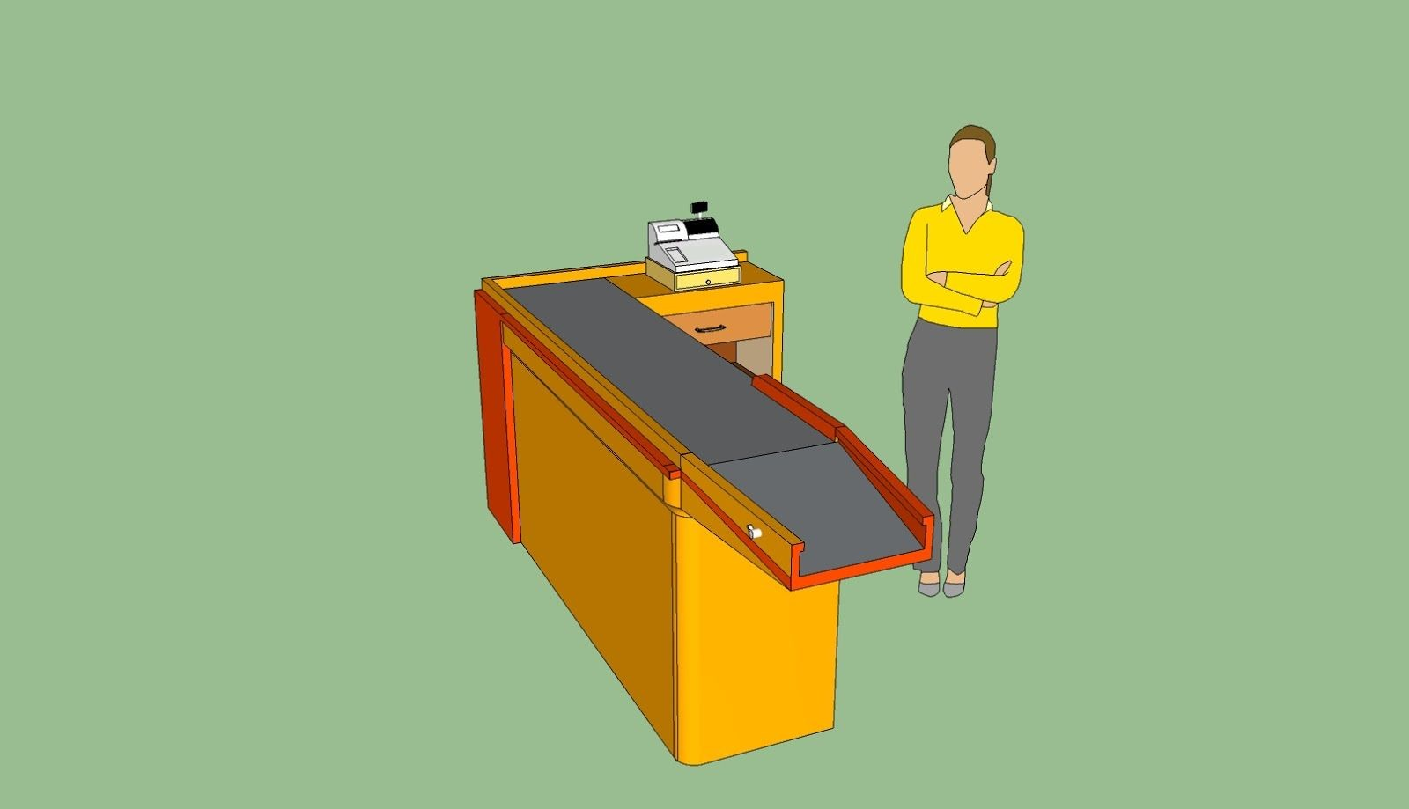
V.3. Cost

This table cashier has a simple model and structure, this table can be produce by a environtmentally friendly, low cost materials. treatment and repairing cost is low because the table designed minimalism which is very efficient and cheap..

